**Boolean Logic**

Not gate – flips the answer

And gate – both inputs need to be 1 for output to be 1

Or gate – one input needs to be 1 for output to be 1 includes both inputs

X or gate – only 1 needs to be 1 for output to be 1 not both inputs

Task 4

A not = E B and = c not = D

|  |  |  |  |  |
| --- | --- | --- | --- | --- |
| A | B | E | C | D |
| 0 | 0 | 1 | 0 | 1 |
| 0 | 1 | 1 | 1 | 0 |
| 1 | 0 | 0 | 0 | 1 |
| 1 | 1 | 0 | 0 | 1 |

Task 5

F =NOT ((A OR B) OR B)

|  |  |  |  |  |
| --- | --- | --- | --- | --- |
| A | B | C | D | E |
| 0 | 0 | 0 | 0 | 1 |
| 0 | 1 | 1 | 1 | 0 |
| 1 | 0 | 1 | 1 | 0 |
| 1 | 1 | 1 | 1 | 0 |

|  |  |  |  |
| --- | --- | --- | --- |
| A | B | Q = A AND B | P = NOT Q |
| 1 | 1 | 1 | 0 |
| 1 | 0 | 0 | 1 |
| 0 | 1 | 0 | 1 |
| 0 | 0 | 0 | 1 |

|  |  |  |  |  |
| --- | --- | --- | --- | --- |
| A | B | E | C | D |
| 0 | 0 | 1 | 0 | 1 |
| 0 | 1 | 1 | 1 | 0 |
| 1 | 0 | 0 | 0 | 1 |
| 1 | 1 | 0 | 0 | 1 |

|  |  |  |  |
| --- | --- | --- | --- |
| A | B | C | S |
| 0 | 0 | 0 | 0 |
| 0 | 1 | 0 | 0 |
| 1 | 0 | 0 | 0 |
| 1 | 1 | 1 | 1 |

EXAM Q ) S A AND S C

|  |  |  |
| --- | --- | --- |
| S A | S C | S G |
| 0 | 0 | 0 |
| 1 | 0 | 0 |
| 0 | 1 | 0 |
| 1 | 1 | 1 |

1)

Q = (NOT A) XOR (NOT B)

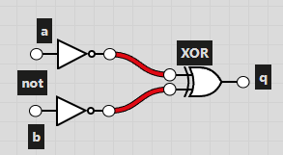

2)

Q = (A AND B) OR ((NOT C) AND D)

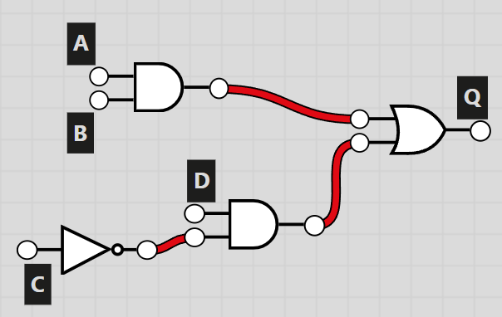

3)

Q = NOT(A OR B) AND NOT (C AND D)